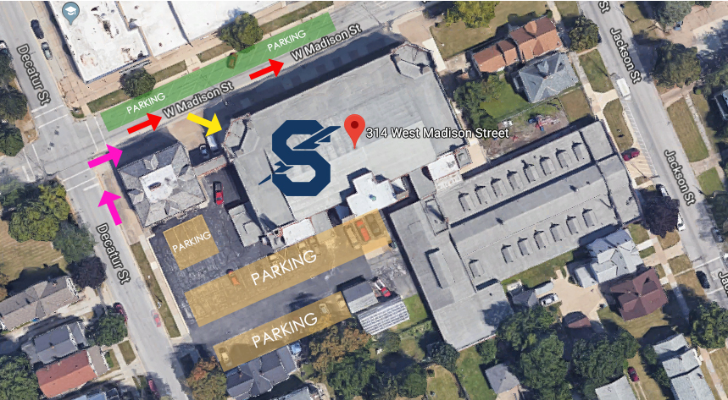

Directions to the Old Jackson Jr. High School
(314 W. Madison St., Sandusky, OH 44870)
From Route 2 east or west, exit at Rt. 4., take Route 4 North (Hayes Ave.) 2.7 miles, past Sandusky High School and into town, until you come to Decatur Street (aka: Cook Way on some GPS units) on the Left, just past Firelands Regional Medical Center, parking garage on the corner.
Turn Left on to Decatur St., travel approximately .2 miles, and the street will bend to the right, through first traffic light at Monroe St. to the next traffic light, which is W. Madison.
Turn Right on W. Madison St. and the school is on the Right.
Parking is on the street marked in green and there is some parking in the lot off Decatur St., behind Jackson marked in orange. If you park in the orange parking lot, please follow the pink arrows around the buildings to the front entrance. Above is a map for Sandusky Middle School’s gym where volleyball and basketball are played. The entrance address is 314 W. Madison Street. The yellow arrow is the entrance to the gym. The Sandusky logo is where the game is played. The red arrow signifies a one-way street and direction of flow. Bathrooms and concessions are available at this location.

